

1

**INTRODUCTION**

The project titled E-Library is Librarymanagement software for monitoring and controlling the transactionsinal library . The project “**E-Library”** is developed in C , which mainly focuses on basic operations in a library like adding new member , newbooks , and updating new information , searching books and members and facility to borrow and return books . “E-Library” is a windows application written for 32-bit Windows operating systems , designed to help users maintain and organize library . Our software is easy to use for both beginners and advanced users . It features a familiar and well thought out , an attractive user interface , combined with strong searching Insertion and reporting capabilities . There port generation facility of library system helps to get a good idea of which are the books borrowed by the members , makes users possible to generate report’s hard copy .The software E-Library has four main modules.

* Insertion to Database Module – User friendly input screen
* Extracting from Database module – Attractive Output Screen
* Report Generation module – borrowed book list & Available book list
* Search Facility system – search for books and members



2

**SYSTEM ANALYSIS**

**EXISTING SYSTEM:**

System Analysis is a detailed study of the various operations performed

by a system and their relationships within and outside of the system . Here the key question is – what all problems exist in the present system ? What must be done to solve the problem ? Analys is begins when a user or manager begins a study of the program using existing system .

During analysis , data collected on the various files , decision points and transactions

handled by the present system . The commonly used tools in the system are Data

Flow Diagram , interviews , etc . Training , experience and common sense are required

for collection of relevant information needed to develop the system . The success of

the system depends largely on how clearly the problem is defined , thoroughly

investigated and properly carried out through the choice of solution . A good analysis

model should provide not only the mechanisms of problem understanding but also the

frame work of the solution . Thus it should be studied thoroughly by collecting data

about the system . Then the proposed system should bean alyzed thoroughly in

accordance with the needs .

System analysis can be categorized into four parts .

* System planning and initia linvestigation
* Information Gathering
* Applying analysistools for structured analysis
* Feasibility study
* Cost/Benefitanalysis.

3

In our existing system all the transaction of books are stored manually , So taking more time for a transaction like borrowing a book or returning a book and also for searching of members and books . Another major disadvantage is that to preparing the list of books borrowed and the available books in the library will take more time , currently it is doing as a one day process for verifying all records . So after conducting the feasibility study we decided to make the manual Library Management System to be computerized.



4

***PROPOSEDSYSTEM***

Proposed system is an automated Library Management System . Through our Software

“E-Library” user can add members , add books , search members , search books , update

information , edit information , borrow and return books in quick time . Our proposed system

has the following advantages .

* User friendly interface
* Fast access to database
* Less error
* More Storage Capacity
* Search facility
* Look and Feel Environment
* Quick transaction

All the manual difficulties in managing the Library have been rectified by implementing computerization.



5

**FEASIBILITY ANALYSIS**

What ever we think need not be feasible . It is wise to think about the feasibility of any problem we undertake . Feasibility is the study of impact , which happens in the organization by the development of a system . The impact can be either positive or negative . When the positives nominate the negatives , then the system is considered feasible . Here the feasibility study can be performed in two ways such as technical feasibility and Economical Feasibility.

**Technical Feasibility:**

We can strongly says that it is technically feasible , since there will not be much difficulty in getting required resources for the development and maintaining the system as well . All there sources needed for the development of the software as well as the maintenance of the same is available in the organization here we are utilizing the resources which are available already .

**Economical Feasibility:**

Development of this application is highly economically feasible . The organization needed not spend much mone for the development of the system already available . The only thing is to be done is making an environment for the development with an effective supervision . If we are doing so , we can attain the maximum usability of the corresponding resources . Even after the development , the organization will not be in a condition to invest more in the organization . Therefore , the system is economically feasible.



6

**HARDWARE CONFIGURATION**

**Processor : PentiumIII630MHz**

**RAM : 512MB**

**HardDisk : 10GB**

**Monitor : 15” Color monitor**

**KeyBoard : 122Keys**



7

**SOFTWARE CONFIGURATION**

Operating System : WindowsXP,Windows7,Windows8.

Language:C

Database:MSAccess2007.



8

**SYSTEM REQUIREMENTS**

This management system can be used in windowsXP,Windows7,Windows8 and , supported for other platform such as UNIX .

The system must be running Windows Xp , Windows7,8 . 0perating system and must meet the following hardware requirements.

* For WindowsXp based computers , a 486/66MHz or higher processor with 500MB
* For Windows7 based computers , a 500/88MHz or higher processor with 500Mb of RAM
* For Windows8 based computers , a 488/66MHz or higher processor with 1gb of RAM
* For Windows2000 based computers , a 700/850MHz or higher processor with 512MB of RAM



9

**DATA FLOW DIAGRAM**

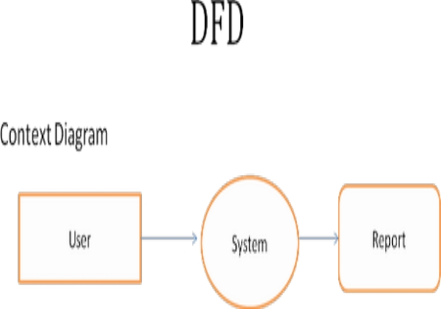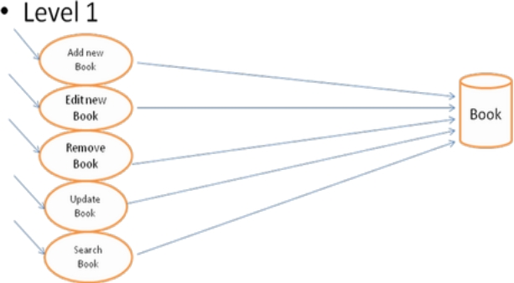

10

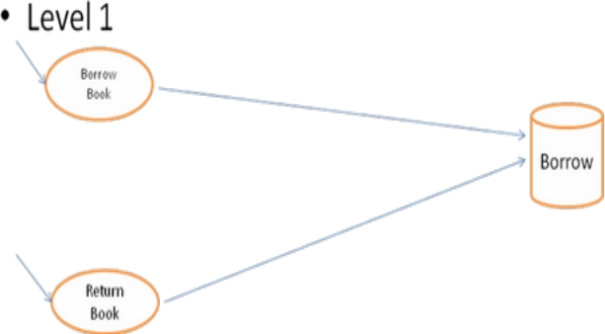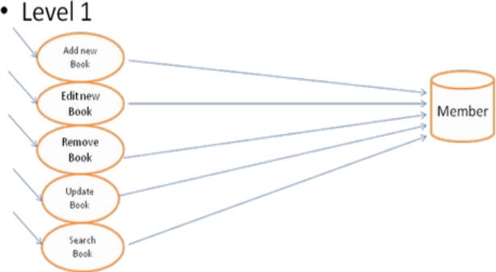

11



12

**SOFTWARE INTERFACE**

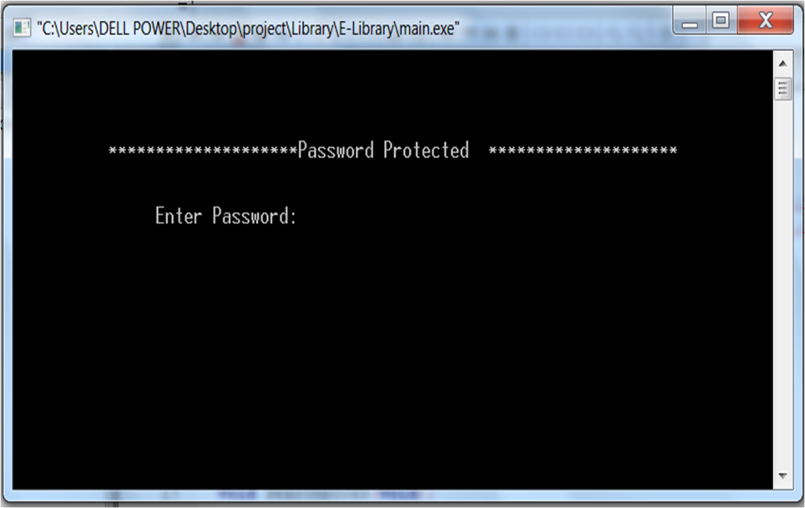

**Listing All Books**

13

**AvailableBooks**

**Borrowed Books**

14

**RemoveBook**

**Edit Book Details**

15

**AddaMember**

16

**ListingallMembers**

**Editamember**

**Remove a member**

17

**SearchforMembersandBooks**

BorrowBooks

Returning a Book

18

ListofIssuedBooks

Reserve a Book



19

**ER-DIAGRAM**

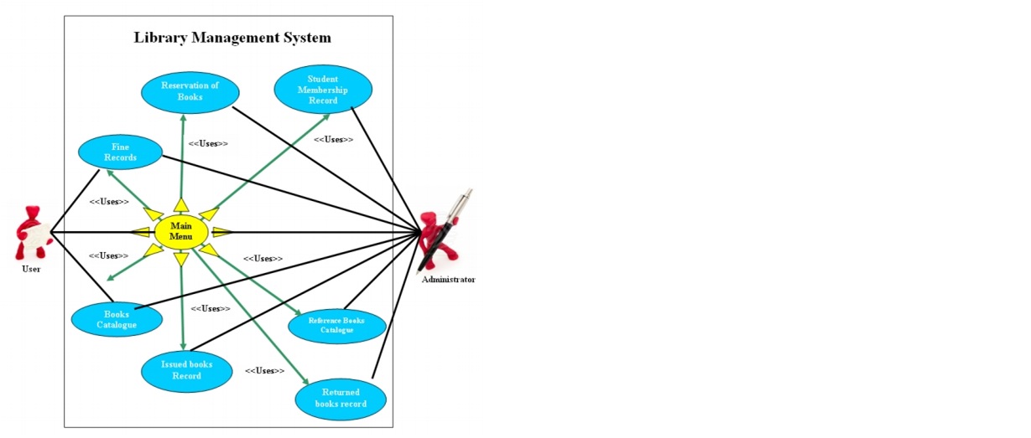

**SYSTEM DESIGN**

**INPUT DESIGN :**

Input design is the process of converting user – oriented input to a computer based format . Input design is a part of over all system design , which requires very careful attention . Often the collection of input data is the most expensive part of the system . The main objectives of the input design are…

1.Produce cost effective method of input

20

1. Achieve highest possible level of accuracy
2. Ensure that the input is acceptable to and under stood by the staff.

Input Data-

The goal of designing input data is to make enter easy , logical and free from errors as possible. The entering data entry operators need to know the all located space for each field ; fields equence and which must match with that in the source document . The format in which the data fields are entered should be given in the input form . Here data entry is online ; it makes use of process or that accepts commands and data from the operator through a keyboard . The input required is analyzed by the processor . It is then accepted or rejected . Input stages include the following processes

* Data Recording
* Data Transcription
* Data Conversion
* Data Verification
* Data Control
* Data Transmission
* Data Correction

One of the aims of the system analyst must be to select data capture method and devices , which reduce the number of stages so as to reduce both the changes of errors and the cost . Input types , can be characterized as

* External
* Internal
* Operational
* Computerized
* Interactive

Design is rather complex since it involves procedures for capturing data as well as inputting it to the computer .

21

**OUTPUT DESIGN**

Out puts from computer systems are required primarily to communicate the results of processing to users . They are also used to provide a permanent copy of these result for latter consultation . Computer output is the most important and direct source of information to the users . Designing computer output should proceed in an organized well through out the manner . The right output must be available for the people who find the system easy ouse . The outputs have been defined during the logical design stage . If not , they should defined at the beginning of the output designing terms of types of output connect,format,response etc.

22

Various types of outputs are

External outputs

Internal outputs

Operational outputs

Interactive outputs

Turn around outputs

All screens are informative and interactive in such a way that the user can full fill his

requirements through asking queries.

**DATABASE DESIGN :**

The general theme behind a database is to handle information as an integrated whole . A database is a collection of interrelated data stored with minimum redundancy to serve many users quickly and effectively . After designing input and output , the analyst must concentrate on database design or how data should be organized around user requirements . The general objective is to make information access easy ,quick , inexpensive and flexible for other users . During database design the following objectives are concerned :-

* Controlled Redundancy
* Data independence
* Accurate and integrating
* More information at low cost
* Recovery from failure
* Privacy and security
* Performance
* Ease of learning and use

**TABLES USED:-**

**Table Name : Books**

|  |  |  |
| --- | --- | --- |
| **Field Name** | **Data Type** | **Description** |
| Book Id | Auto Number | Primary Key |
| Subject | Text(30) | - |
| Title | Text(30) | - |

24

|  |  |  |
| --- | --- | --- |
| Author | Text(25) | - |
| Publisher | Text(25) | - |
| Copyright | Number | - |
| Edition | Number | - |
| Pages | Number | - |
| ISBN | Text | - |
| Number Of Books | Number | - |
| Number Of Availble Books | Number | - |
| Number Of BorrowedBooks | Number | - |
| Library | Text(25) | - |
| Availble | Yes/No | - |
| Shelf No | Number | - |

**Table Name : Borrow**

|  |  |  |
| --- | --- | --- |
| **Field Name** | **Data Type** | **Description** |
| Book Id | Number | Primary Key |
| Member ID | Number | - |
| Day Of Borrowed | Date/Time | - |
| Day Of Return | Date/Time | - |



25

**Table Name : Members**

|  |  |  |
| --- | --- | --- |
| **Field Name** | **Data Type** | **Description** |
| Member Id | Auto Number | Primary Key |
| ID | Number | - |
| Password | Text(10) | - |
| NAME | Text(25) | - |
| EMAIL | Text(25) | - |
| Major | Text(10) | - |
| Number Of Books | Number | - |
| Mony | Number | - |
| Expired | Date/Time | - |

**SYSTEM IMPLEMENTATION**

Implementation is the stage in the project where the theoretical design is turned into a working system . The implementation phase constructs , installs and operates the new system. The most crucial stage in achieving a new successful system is that it will work efficiently and effectively .

There are several activities involved while implementing a new project they are

26

* End user training
* End user Education
* Training on the application software
* System Design
* ParallelRun And To New System Post implementation Review

**End user Training:**

The successful implementation of the new system will purely upon the involvement of the officers working in that department . The officers will be imparted the necessary training on the new technology .

**End User Education :**

The education of the end user start after the implementation and testing is over . When the system is found to be more difficult to understandand complex , more effort is put to educate the end user to make them aware of the system , giving them lectures about the new system and providing them necessary documents and materials about how the system can do this .

**Training of application software :**

After providing the necessary basic training on the computer awareness , the users will have to be trained upon the new system such as the screen flows and screen design type of help on the screen , type of errors while entering the data , the corresponding validation check a teach entry and the way to correct the data entered . It should then cover information needed by the specific user or group to use the system .

**Post Implementation View :**



27

The department is planning a method to know the states of the past implementation process . For that regular meeting will be arranged by the concerned officers about the implementation problem and success.

**SOFTWARE TESTING**

Is the menu bar displayed in the appropriate contested some system related features included either in menu sortools ? Do pull – Down menu operation and Tool –bars work properly ? Are all menu function and pull down subfunction properly listed? ; Is it possible to invoke each menu function using a logical assumptions that if all parts of the system are

28

Correct , the goal will be successfully achieved . ? In adequate testing or non – testing will eadsto errors that may appear few months later .

This create two problem

1. Time delay between the cause and appearance of the problem .
2. The effect of the system error some files and records with in the system

The purpose of the system testing is to consider all the likely variations to which it will be suggested and push the systems to limits .The testing process focuses on the logical intervals of the software ensuring that all statement shave been tested and on functional intervalis conducting tests to uncover errors and ensure that defined input will produce actual results that agree with the required results . Program level testing , modules level testing integrated and carried out .

There are two major type of testing they are

1. WhiteBox Testing.
2. BlackBox Testing.

**WhiteBox Testing :**

Whitebox some times called “ Glassbox testing ” is a test case design uses the control structure of the procedural design to drive test case .

Using whitebox testing methods , the following tests where made on the system



29

A) All independent paths with in a module have been exercised once . In our system , ensuring that case was selected and executed checked all case structures . The bugs that were prevailing in some part of the code where fixed .

b) All logical decisions were checked for the truth and falsity of,the values .

**Blackbox Testing :**

Blackbox testing focuses on the functional requirements of the software . This is blackbox testing enables the software engineering to derive asset of input conditions that will fully exercise all functional requirements for a program . Blackbox testing is not an alternative to whitebox testing rather it is complementary approach that is likely to uncover a different class of errors that whitebox methods like..

1. Interface errors
2. Performance in datastructure
3. Performance errors

4) Initializing and termination errors

**CONCLUSION**



30

Our project is only a humbleventure to satisfy the needs in a library . Several user friendly coding have also adopted . This package shall prove to be a powerful package in satisfying all the requirements of the organization .The objective of software planning is to provide a framework that enables the manger to make reasonable estimates made within a limited time frame at the beginning of the software project and should be updated regularly as the projectprogresses.